

One Day Show: October 17, 2015

**Granbury Ag Science Complex**

**451 Howard Clemmons Drive, Granbury, Texas**

Show Schedule:

Heifer Check in/Steer Weigh –in: 6:30am-8:00am, Heifer Show Starts at 9:00am, Followed by Steers

Lamb/Goat Weigh-in: 11:30pm -1:00pm

Lamb/Goats Showing at same time divided arena

Both Shows starting at 2:00pm

Show Information:

Entry Fee: $20 at the door

We Weigh/You Classify/No Weigh Back

Not a Sanctioned Show

Blow & Go ONLY, Wash Rack Available

Trailer Parking available and generators are welcome

Jackpot Showmanship (*Junior* 13 & under & *Senior* 14 & up)

$5/head at the gate winner take all, Following each Show

Prizes:

Buckles to Grand Champions

Chairs to Reserve Grand Champions

Prizes to Breed and Reserve Breed Champions

Placing Ribbons 1st-4th Place

Classifications:

Cattle- American, British, Exotic

Sheep-Dorper, FW/FWX, Southdown and Medium Wool

Goats- Light, Medium & Heavy Division

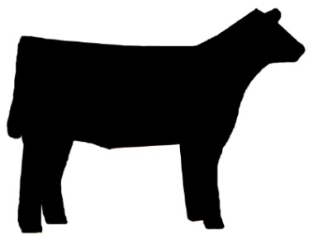Judges:

Cattle: Eric Kale

Lamb: Robby Blakley

Goat: Stewart Spruill

**For More Information: Granbury Ag Department 817-408-4642**

**shaina.seabourn@granburyisd.org**